.

**Chapter 30 – HOME IN ERDA at 2448 W Erda Way – Aug 1976 to June 1979**

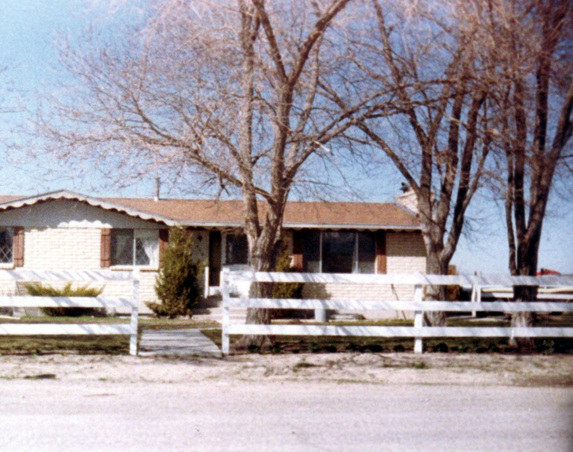

We moved to Erda the lst of September 1976. We had sold our home in Taylorsville to a young couple named Roger and Debbie Yetter. Debbie goes to church and would like to be active, but Roger smokes and isn’t active. We sold our home to them for just what we had put into it. (Our down payment, the extra money to get better carpeting and the cost of the materials when Ken built the two extra bedrooms in the basement.) Everyone thought we were crazy to let it go for just that, and not make any money on the home because those homes had gone up in value about $5,000. In just the 10 months that we had lived there. But, we had talked to the realtor prior to selling the home and asked what it was worth. He told us we should be able to get all the money we had put into it out - so we thought that was a fair amount. We were wrong. No wonder we had sold it so quickly. It sold the day we put the sign up.

**MOVING TO ERDA BEFORE THE HOME WAS FINISHED**

The couple who bought our home in Taylorsville wanted to move in by the first of September, and our home in Erda was supposed to be finished and ready for us to move into by the 23rd of August. We were happy about that as we wanted to start our children in school out there. The schools were located in Tooele, so we got them registered. Sandi went to Tooele High, Shellie to the middle school and Mike and David to the Elementary. Our home was not finished, however, but we got permission to move into it anyway. The pre-fab home was set onto the basement, but the windows were not in yet, so there were tons of flies going in the windows and coming up the basement steps into the home. This is a farming community so our neighbors had horses, cows, sheep, etc. The flies were miserable. A company had dug the hole and put in a septic tank, but at that time, the home hadn’t been delivered and set on the basement, so he couldn’t dig the trench, with his equipment, to put in the sewer lines from the septic tank to the house. This meant that we had to put a five-gallon bucket with a toilet seat on it in the bathrooms for us to use. That wasn’t so great either, especially with seven of us. We didn’t have electricity, so we used a Coleman stove to cook on and a Coleman lantern to see by at night, plus flashlights. We used coolers to put our frozen and items that needed refrigeration, in and used dry ice that we had to get frequently.

The thing I enjoyed getting the most was the basement windows, so we could manage the flies. We then got electricity and our appliances, so we could have a real kitchen with fridge, stove, etc. We had a well, so had to carry in water until the plumbing was completed. The man who put in the septic tank was too busy now to come out and dig our trench and put in the sewer lines, so Ken finally did it himself. We were all much happier now. Our home was then bricked, fireplaces put in, outside steps going into the home from the front and back doors, sidewalks, and a rail fence around the yard. It turned out beautiful. Ken was able to finish the basement the following winter and it was beautiful. We had a wonderful family room. In the family room, Ken built a platform when he put a wood burning stove on and also built a bench in front of the platform which went from the north wall to the south wall. In the cement, Ken let the children put their hand prints, which was encased by the bench. The carpet was a beautiful brown. We had many family, friend and church parties and firesides in this family room. We also had the Porter clan here for Thanksgiving. I’ve already told, in this history, about the other basement rooms, Ken built for our three sons and Shellie.

We take so many things for granted, when we have had all these luxuries in the past, and then to go without them, sure makes you appreciate them lots more. We know there are many in the third world countries who don’t have these luxuries. When my brother, Terry, returned from his mission to Germany, he told us that the wealthy who lived in castles didn’t have central heating and wall to wall carpets, like we do, and he sure appreciated coming home to them.

We were able to pick out the plans for an Interstate prefab home. It is 12 hundred 48 square feet. It has three large bedrooms upstairs, two baths, one being off the master bedroom. It has large closets with bileveled bifold doors - dark brown. The trim all over the home is dark wood. The kitchen and bathrooms have walltex on the walls. We were able to pick out the patterns. The kitchen has a U shape working area with a long counter dividing the working area and the dining area. We picked white Formica for the counter tops. We bought green sheers for the patio window with green and white drapes and green sheer curtains above the window. We also bought us a new fridge so I really love my kitchen, in fact, the whole house. From the kitchen there’s little bar doors that separate the mud room where my washer and dryer are and also the pantry. Then there is the back door going outside. There’s an entrance from the front door to the rest of the house. We picked out mill block paneling for the one wall in the front room and wall going downstairs. The entrance way is done in it also. The front room has a beautiful rock fireplace on the same wall as the paneling. We picked out blue and green floral drapes that go to the ceiling with while sheers. Our carpet is green in the living room and two bedrooms and orange in the master bedroom and down the hall. The outside of the home is beautiful also with a southern effect. It has scalloped trim, brown shudders, yellow brick with a while entrance and front door. The windows have a criss cross pattern in them. We’re going to put up a white rail fence. The farm committee are really wonderful especially President Labrum and Bishop Steadman in wanting us to have a nice home here and helping us to get it. The farm is really great. The children have two dogs and several cats. There are 81 head of cattle on the farm also, so they have animals to care for. We hope to get some horses next spring. There’s three hundred and 47 acres of land here. Most of it is in hay so it’s green and pretty all spring, summer and fall. The children can learn the value of work and be with their dad also. Scott is 2 ½ years old now and he just loves being with his dad. In the morning he’ll say “wait for me, Dad”. I’ll see the two of them outside in the mornings after the other children have gone to school, and he’ll be following Ken everywhere. Sometimes they go hand in hand. It sure looks cute and it makes me feel so good that Ken is so good with the children and loves to have them with him. Scott loves to ride with his dad in the big tractor also. It is a big John Deer and has a cab. Ken tells Scott story after story as they ride while plowing, harrowing, disking, etc. Scott sometimes catches his dad varying from the story and corrects him. Ken tries to trick Scott, but Scott catches him every time.

**Ken sure is happy working on the farm. It’s what he’s always wanted**. The farm committee 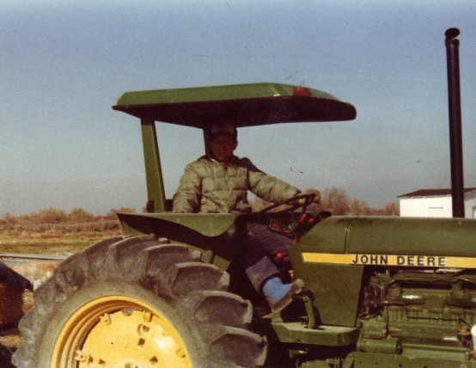bought two tractors for him. One, the smaller, with a canopy over it and the other is a beautiful big tractor with a cab, air conditioning, heating, cushioned seat, adjustable steering wheel, etc. Ken was talking to his stepfather a while ago and they were comparing how he used to plow with his horse and hand plow and now look at Ken’s big tractor and how he plows. The farm committee also bought Ken a nice pickup truck, a land plain, swather, and everything he needs to do a first-rate job of farming. We never could farm like this even if we could afford to buy our own farm.

Some of the benefits of this job are: The home, they pay our utilities, we get a beef a year, we get our milk at the dairy farm free, and they also have good insurance and retirement benefits. We feel really good here and we are thankful to the Lord for guiding us here**.** The children are all happy, they have good friends. Sandy is especially happy that we moved and she was the one I was worried about because she was 14, had her friends, had her classes in school already picked out, she was going to be an office aid and in the school choir. When she found out about the farm, she cried and was unhappy because we had moved so often and it was hard for her to adjust, although she makes friends easily usually. She has been the happiest, other than Ken and I, since the move. This is a big ward with lots of teenagers - so she has lots of friends and boys she likes. She is in high school since they have the four-year high school - so she’s involved in activities there. She is also in concert choir which she enjoys. I just made her dress for it. They sing in Sacrament meetings of other wards quite often and also other churches. She takes seminary and really loves it. She has the “neatest teacher” she says, and they voted her in as class secretary. They have lots of activities with the seminary also. She plays the piano for APYW activity nights and she also played for the roadshow along with doing a lot of the art work for the scenery. They put the roadshow on last night in Wendover and they also put it on Tuesday and Wednesday nights in other wards.

When Casper was killed by the tractor, a neighbor in Taylorsville heard about it and they had a large dog, which was too big for a sub division and asked if we would take her out to the farm. We did and we liked her, but she got running with other dogs in the neighborhood and they were killing chickens and turkeys. When a neighbor saw our dog with the other dogs and said they had killed his chickens, we offered to pay for the chickens and we had our dog put to sleep as once they start doing that, they don’t stop. We got another dog and we named it “**Spunky”.** That was such a cute dog. It wasn’t Casper, but it was special also. It had black and white long hair. It had such a cute personality. When you talked to it, it would cock its head back and forth as though it understood everything you said. He would love to run and play with the children - I loved to play with it too. I remember starting to run with it - or when the children did, and it would run so fast around and around you and we would be laughing so hard. Finally, it would stop and come over and lay its head on your lap. I was laughing so hard I couldn’t stand so would sit or lay on the grass. We loved that dog also. We had two ducks while on the Erda Farm and some cats. One of the ducks ate poison oats, which Ken had to kill the gophers in the fields. Ken’s farm helper had spilled the oats as he was filling the machine. Ken had warned him about this since we had several animals, so he felt bad when the pet duck died. The other duck was so distraught that she wouldn’t leave her mate. Ken had to force her off so he could bury the dead one. This while duck (don’t remember their names) wouldn’t eat so we thought we would lose it too, but finally we noticed it following Spunky around and it was starting to eat again. One morning I went outside and found Spunky laying down in the shade, the duck was laying by him with her head on his back and the cat was snuggled up beside them. It was so cute, I wish I had taken a picture of them. From then on, you would see Spunky walking with the duck behind and the cat behind her. What a sight to see. They were great friends until the duck got out in the front yard and close to the street and someone drove off the street to hit the duck. We were so sad and upset that someone would do that. We have been fortunate to have many special pets.

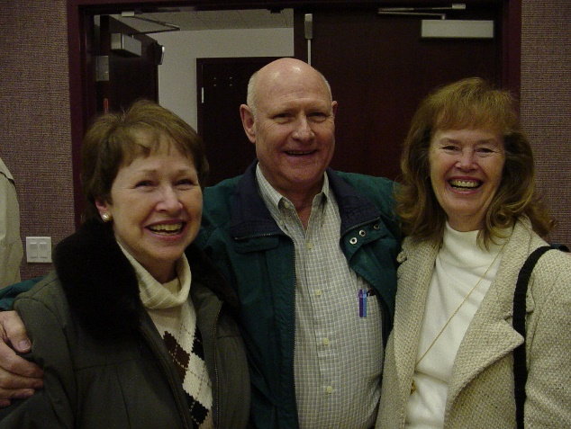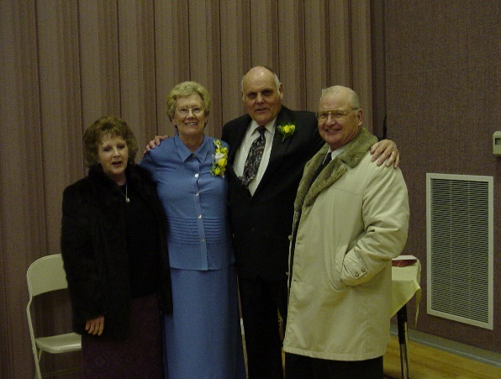 Ken and I have some wonderful friends here in Erda also. **Vern and Diane Pancratz manage the Granger Stake Farm about one mile up the road from us so they are also in our ward**. They have 8 children. They’re very special people. Ken & Vern help each other sometimes on their farms. We have a lot in common with them and enjoy being with them. We go to the temple with them and other places, and to each other’s homes quite often. They planted a large garden so they’ve given us a lot of vegetables from it. Also, several hundred pounds of potatoes for this winter. We’re very grateful for their generosity and friendship. **Tom and Karen Egglund** live close by us and they’ve been so good to us. They helped us move in, brought us vegetables and other food, invited us to their home for homemade ice cream and cake, invited us to go square dancing with them and many other places. Tom and his son, Kent, helped Ken on the farm some this spring and summer. (The picture above is of Tom & Karen in the center and Dianne and Vern on the outside.) I went to school with the **Bishop’s wife, Colleen Gordon.**  Colleen always had a sweet smile then and she still does. We’ve enjoyed going to the temple with them and other places. Their daughter, Ronna, is my class president of the lst year Beehives. I enjoy teaching this class. The girls are reverent, yet they participate and are enthusiastic about everything. Ken teaches the 17-year old’s in Sunday School and loves it. These youth are very respectful and reverent also.

We have wonderful neighbors also.

**Tim and Carol Smith** live across the street from us. (I wish I had a picture of them). His mother, **Mary**, lives next to them and his brother, **Pete and his wife, Gale** live next to Mary on the west side. They are all very wonderful. Ken has had to borrow things from them and they are so willing. None of them, except the mother, **Mary,** are very active, but they would give you the shirt off their back. I especially love Carol. She was bringing food over when we were moving in. I’ve visited a lot with her and think she is really special. She’s always doing nice things for me or giving me things. She painted a pumpkin for us and put a hat on it then gave it to us for Halloween. She has given me lots of clothes for Scott that her son, Chris, has outgrown. They’re almost like new. She gave Scott a cowboy hat that he loves. A couple of days ago she brought over a beautiful bedspread that had just the colors of my bedroom in it. She was cleaning her linen closet and found it. It used to be her daughter’s. It’s almost like new too. She was wondering if I might like it. I had been using a blue and white one that was wearing out. Ken’s Mom had given it to me. My colors in that bedroom are orange and green, so that bedspread which she gave me makes the room look much better. Carol is so thoughtful and friendly. I have given her a few things (food that I bake, mainly), but I don’t feel I ever get caught up as she is always doing things for me. Carol doesn’t have many friends. She is shy and maybe some of it has to do with her being inactive in the church, because most of my other neighbors and people out here are members of the church and are active. They should fellowship them more, - but anyway I sure enjoy her.

**Laura and Dennis Hanes** live up the street. They brought in a big dinner for us a couple of nights after we moved in. They are very friendly and great too. In fact, all the people here in this ward are just great and have really welcomed us in with open arms. At church, one of the men said to Ken “You’re just family. You were meant to come here”. We have loved the area, neighbors, ward, etc., from the day we moved in.

They asked me to teach the lst year Beehives. I have six girls - Lorene Brush, Ronna Gordon, Brenda Warr, Tammy Warr (they’re cousins), Robin Lemmer and Genene Russell. They’re all fairly active except Genene. She was put in as lst counselor in the class presidency in hopes it would activitate her. She promised Bro. Brown in the Bishopric that she would come for at least six weeks. She came most of those weeks, but now we can’t get her to come out. For her birthday I made her a cake and took over to her, and I’ve been to see her several times and called her and also the girls have, but to no avail. Hope we can think of some way to help her want to come back.

Ken is teaching the 17 & 18-year-old youth. They’re really a special group. He has about 18 and they’re all reverent and spiritual. I really have grown to love my beehive girls also.

**World conditions are looking bad. The economy is in sad shape. Inflation is so high and keeps climbing.** We are having a drought (no moisture) here in the west, and in the East, they are having blizzards - so much snow that the schools are closed and many businesses are closed. The weather is way below freezing. **The people are having to pay $100. a month and higher for their fuel to heat their homes. We are paying around $34.00 a month**. Many of the people can’t afford this so they are keeping their children in bed to keep their warm, and of course, they still aren’t very warm**. If things don’t change neither the East or the West will be able to plant crops and a famine will occur.** **Both the stake president, President Labrum, who is over the farm committee, and President Johnson, our stake president has said that if the members of the church don’t have their year’s supply of food and other necessities by now, they are on dangerous ground. President Kimball told us in conference last April that we should have our year’s supply by next April. It is now February**. We have a lot of storage, but we don’t feel it will be enough. We are still working to get it.

They just put Ken in as a counselor in the High Priest Quorum and a home teacher so he’s plenty busy and I’m also a visiting teacher.

**JOURNAL ENTRIES starting from January 1st, 1977, while living in ERDA**

Jan 1st - Rick & Georgia spend the night and left about 11:30 am. Vern, Diane and their family came over for supper and played games.

Jan 6th - Ken and I went to the Salt Lake Temple where we were asked to be witnesses which is a very special experience. We ate in the cafeteria and had a wonderful day.

Jan 10th - Mom & Dad Porter came out for supper and Family Home Evening which they do quite frequently. They enjoy being with us for Family Home Evening and we enjoy having them with us. It makes it extra special. Mom usually helps bring the refreshments.

Jan 17th - We got our first farm raise.

Jan 22nd - We visited with Bob & Carroll, then played games at Bryce & Deanna’s and spent the night. We had a great time.

Jan 23rd - We visited with Dad & Mom Porter in the morning and Dad & Mom Jensen in the afternoon.

Jan 27th - Ken started for the 1st of 3 days with the church Seminar in Idaho.

Jan 29th - Scott’s third birthday.

Feb 8th - Sandy was sustained as APYW organist

Feb 12th - We bought 25 chickens from Russ & Kathy at the dairy farm. The egg business hasn’t been too profitable for us though.

Feb 15th - Sandy was elected queen of the youth Valentines dance. The youth elected her.

Feb 20th - Ken and I sang in the choir for stake conference. We had a new stake presidency put in. That night Elder Gordon B. Hinckley dedicated our ward chapel as it had been remodeled.

Feb 25th - We had a dinner party at our home tonight. Seven couples came and we all had a very nice evening. It is a group of friends that Tom & Karen Eglund invited us to join in with.

Feb 27th - Ken’s birthday. Ken stood in the circle to help confirm Cindi (Hal & Jean’s daughter) as a member of the church in her ward. Then we went to Ken’s parents where they had a birthday dinner for Ken. Bob, Carroll and family were there also.

Mar 4th - Ken & I went to the Salt Lake temple with Roy & Roena Bryan. She teaches the other 1st year Beehive class and is a very sweet lady. We ate in the cafeteria which was nice. We took Sandy & her friends to Kerns to go roller skating in the evening, then the rest of our family went to a show.

Mar 5th - Ken & I went to a ward dance. It was a western dance and really fun.

Mar 6th - Sandy & Shellie bore their testimonies. We are sure proud of them. We visited with Pankratz (Vern & Diane) for a while and then went to our High Priest study group where Ken gave the lesson.

**Experience of Shellie falling from truck in Erda**

In September of 1978, Ken had asked Sandy to take the truck and go into Salt Lake to get parts for him for the farm. The Dairy Farm had borrowed our truck and left us their old red truck. Sandy asked Shellie to go with her. She didn’t want to go because I had told her that she could go to her friend, Angie’s, after school to play. Ken told her to go with Sandy so she was unhappy. She said she didn’t talk to Sandy very much as they rode along, but on the way home, she felt better and they began to talk. As they were nearing the corner by the bottom of our field, Shellie leaned again the door to look at Sandy as they talked. Sandy turned the corner, and it pushed Shellie harder against the door and it came open throwing Shellie out on the road. Sandy quickly stopped the truck and ran and picked up Shellie and came on home. When we saw Sandy carry Shellie into the house, we knew something was wrong. Shellie was scratched really badly from her ankles to her neck, especially on the left side. Sandy felt so bad, but it wasn’t her fault. We are thankful she was able to stop the truck, so that it didn’t run over Shellie. Shellie was wearing shorts so her poor little legs and stomach were really bad. She was in so much pain that I called the doctor. He told me to clean it out, and then put Neosporin ointment on it. I asked him if there was some spray that would numb it as the pain was so bad. He said Americaine was good for that. I quickly went to Tooele to the drug store and got it. The spray had 25% alcohol in it, and she would scream and couldn’t stand for us to put it on. Ken had cleaned it while I was gone. That night poor little Shellie didn’t sleep hardly at all. The next day wasn’t much better. We kept trying to put the Neosporin on, gave her aspirins and did what we could, but finally in the afternoon, she got a fever and started shaking uncontrollably. I called the doctor and he said to take her into the Primary Children’s Hospital.

We were supposed to have a party at our home that evening. It was for the Bishopric, clerks and their wives. Ken felt we should still have it even though I hadn’t been able to clean the house like I wanted to. Everyone was bringing pot luck and I had made salads for it, so Ken stayed here to host the party while I took Shellie in. It was a hot day and she was in a lot of pain on the ride in. I felt so bad for her. I hate to see my children in pain of any kind, and Shellie was in so much pain. I had to take Jeff with me and he was cross so I was really glad when we finally got there. They looked at Shellie and said the fever was brought on by infection that had started because there was still dirt and gravel in the flesh. They said they would have to clean it out. Both Shellie and I were worried because we knew it would hurt terribly. I asked if they could give her something for the pain and they said “no, because she needed to be alert so they could tell by her reactions whether they were cleaning too deep”. I didn’t think I could stand to stay there and see her go through that so I told her I would just be out in the waiting room, but she said “No, Mom, stay here with me”. I could understand that and I did want to help her if I could. I stood by her and held her hand. They used a toothbrush and hydrogen peroxide. They really scrubbed, and poor little Shellie screamed and twisted as she clutched my hand. I wished I could go through it for her and take the pain from her to me. Tears rolled down my cheeks as I knew it was torture for her. I was afraid I would pass out, but I held on for Shellie’s sake. I’m not sure how I did as I pass out so easily. Finally, after what seemed an eternity, they were through. They put Neosporin on and bandaged her all over. They took X rays and found no broken bones. We got home around 10:00 that night. All the guests had gone and they had all had a good time Ken said. They played volley ball in the back yard, then cooked their steaks on the barbecue and had lots of other good food. I was a little embarrassed that the house wasn’t as clean as I would have liked, but I was more concerned about Shellie as she was far more important to me than that party or a clean house.

Shellie got along fine after that and it healed rapidly. We are so thankful that it wasn’t any worse than it was because her little face wasn’t hurt at all. The main thing that we thought about, was if she had leaned on that door while Sandy was turning a corner in a main intersection in Salt Lake City or on the freeway, Shellie would probably have been killed as there was so much traffic. It was during the rush hours - people were getting off work and heading home. She probably would never had a chance. We are so thankful that she is alive. We love her very much. We don’t feel that it was just a coincidence that she didn’t lean against that door earlier; we feel that the Lord watched over her and we are very thankful to him. I felt bad for Sandy while this was all going on. She loved her sister very much too and was so scared and upset and worried. It certainly wasn’t her fault in any way.

**I taught the Beehives until Jeff was born**. Actually, the President, Vida Bates, substituted for me from the 1st of January as David was to have his second operation on his left foot the 1st part of January and I needed to be with him. I thought I would again teach the Beehives after Jeff was a few weeks old, but the ward was divided the last of January and **Ken was put in as lst counselor to Bishop LaDell Brown** so we decided it would be better if I get out of the MIA since we are gone so much in the evenings and it is an involved program and requires a lot of time. I would need to support Ken and be home with the children. I enjoyed teaching the Beehives, and it was rewarding in many ways, but with presidency meetings, extra activities that the girls wanted to go on, service projects with our class and also with the APYW, firesides, doing extra things for each of the girls birthdays, and when they were sick, etc., making visual aids, handouts, etc., for the lessons and going to the stake and ward meetings and then the regular APYW and also we put on a joint activity once a month. It was really a big job. In my class, I had girls that didn’t get along and there were several problems with that also. Some pretty serious and it was hard trying to get them to see the other person’s side of the problem, and to be Christ like, instead of jealous and selfish. I guess I was a little relieved to leave this position. I did grow to love the girls and it was rewarding when they would come to visit me or come up to me at church and tell me things. **When I was released one of my girls came up to me and was very sad and said “First you quit, and now Vida. Now who is there that is really good and cares about us?”** That made me feel sad.

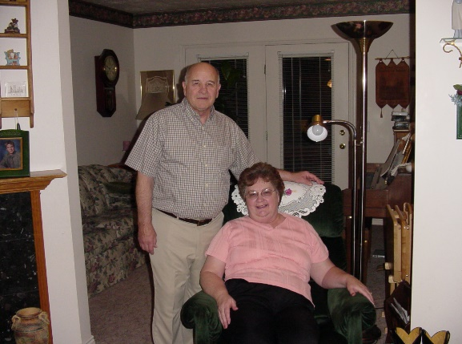We don’t have a picture of Ken being in the Bishopric with LaDell and Cordell Gull. This picture was taken years later when we were visiting them in Tooele, as they had sold their place in Erda and moved to Tooele for their health. We became great friends with LaDell and Eleanor while we lived in Erda. On Friday nights, we would take turns going to each other’s homes and playing games. We had so much fun. Onetime LaDell wanted to show Ken something in their basement and while they were gone, Eleanor said to me: “Let’s stack the deck”, so we did. When they came back, we had dealt the cards out for our game of Rook. As they started to play, Ken said “I pass”, and LaDell looked at him and said “You can’t pass, I have nothing”. Eleanor and I started to laugh as we had given each of us all the good cards and them the bad ones. They always teased us about that after that and said:”we don’t dare leave you too together or you will “stack the deck”. Eleanor drove a school bus to earn some extra money for their family after their youngest went to school. She loved it and told me I should do that, but I told her “No, that’s not for me as I don’t even feel too safe driving my car or truck, so I couldn’t drive a school bus full of children or youth.” I told her that if I went to work, I would be a secretary as that is what I am good at and like to do. It is interesting that Ken became a school bus driver later in life. Ken enjoyed serving with LaDell in the bishopric. Cordell Gull was the 2nd counselor and Ken enjoyed Cordell also. After we moved, LaDell was put in as the stake president.

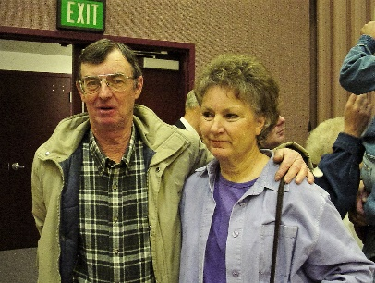 Terry & Sally Matthews were also good friends when we lived in Erda. Sally also drove a school bus and Terry was a supervisor out at Tooele Army Depot. We enjoyed being with them also. We didn’t do as much with them as we did with LaDel and Eleanor Brown, but we enjoyed visiting with them at church and other activities. We didn’t have a lot of time to spend with friends since Ken was running this farm and also in the Bishopric, and I was busy with my family and keeping everything running smoothly – at least I tried to. Several years later, Terry knew we had moved back to Utah, from Arizona, and knew that Ken was very good in construction, so he had his secretary call Ken to see if he would be interested in working in his department at Tooele Army Depot. That turned out to be a blessing also, but Terry wasn’t Ken’s direct supervisor and the supervisor Ken had was not a good man and didn’t know much about building. We had heard that he got this position because he let his wife sleep with one of the generals, and she was a beautiful woman. That might just be a rumor.

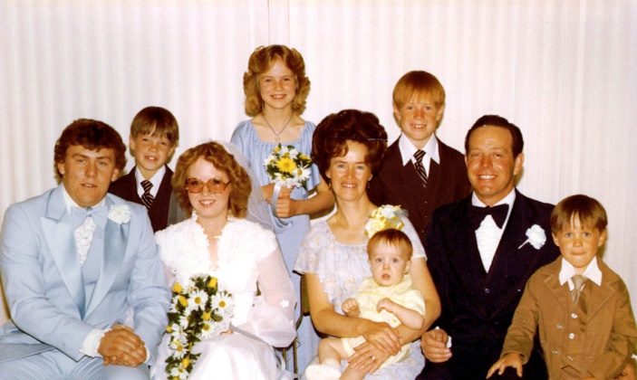**Trials with Sandi and her marriage to David Nix**

This year, 1978/79, has been a trying one. We love our oldest child, Sandi, very much, but we have been having trouble communicating. Her attitude has changed a lot with regards to the gospel over the past 2 ½ years since we have been living in Erda. Ken and I have been talking and asking ourselves why? And how did this come about? I think one incident, a short time after she received her patriarchal blessing, had some influence. She had just turned 14 and was able to receive her blessing. It was a beautiful blessing. We all shed tears and were proud of Sandy. Sometime later, our good friends, the Braithwaite’s, were visiting. Lori, Sandy’s age and good friend, read her blessing. She said to Sandy, “Gosh, it sounds like you’re going to do a lot of bad things”. In her blessing, it gave her words of warning like it did in mine and I suppose it does in all blessings, but since that time, Sandy disliked her blessing and felt the same as Lori had and we couldn’t talk her out of it. I’ve heard people say that you shouldn’t let everyone read your blessing, maybe this is why. Whether this is true or not, her attitude started to change. She wanted to be popular and that was so important to her. I could understand more than her dad. She was a sweet girl and appreciated what I did for her. Her dad didn’t have that desire to wear the latest fashions when he was a kid. The only thing that was important to him was that he felt his clothes looked clean and neat and looked good on him. If our kids wanted something, they better not say - when Ken asked why “because all the other kids have one”, or they wouldn’t get it unless I softened him up. If it was because they wanted it, that was different and he would try to get it or help them find ways to earn the money.

Sandy was chairman of the youth conference during her sophomore year. Our Bishop’s son, Drake Brown was the co-chairman. With this responsibility, she had several fund-raising projects to help the youth raise money to go to youth conference. They went to B.Y.U. First, they had car washes at the church, then they made Mother’s Day cakes. They decorated them at the church and delivered them to the homes when the father’s or children had ordered them. They also had a “Rock-a-Thon” where they brought rocking chairs to the church recreation hall and they brought food, T.V.’s stereos, records, games, books, etc., to entertain them while they rocked. First, they got sponsors - people who would pay them so much an hour to rock. They had 10 minutes each hour to go to the rest room and walk around. Some of them rocked for 24 hours. Sandy was the main one to organize and be in charge. I helped her with most of these projects. They all turned out really well, and I was proud of her. Drake liked Sandi, but kids called him a “Goody Goody” and Sandi didn’t want that label, so she didn’t have much to do with Drake. One time they were at a ward dance and Drake asked Sandi to dance with him and while they were dancing, LaDell remarked to Ken, that they made a great couple. This didn’t sit well with Sandi when her dad told her this. I’m sure her life would have been much better and happier if she had liked Drake and married him instead of David Nix, but we all have our free agency and make our own choices, and the choices we make determine our destiny.

Sandy has had many friends; LuAnn Premack in Mesa was a true friend. Most of her other friends, since that time, have been two faced. They would treat her good and be her friend until someone more popular came along and then they would drop her and go with them. Girls especially are that way. It’s really sad. My neighbor, Carol, has a daughter a year younger than Sandy. Her name was also Sandy. They became friends, but she would make fun of our Sandy in front of other kids and this would really hurt our daughter. Our Sandy finally quit being friends with her and I was glad. Sandy Smith didn’t have many values. Sandy’s other friends in Erda were good girls, but they still were not the best to Sandy many times. Sandy felt bad that she couldn’t find another close friend who would be loyal and kind. I felt so bad when Sandi would come home feeling bad, I wanted to tell those girls off and make them realize how cruel they were.

It’s typical for many teenagers to want popularity. I remember wishing I was more popular. We felt Sandi was different and special, and we love the gospel so much, that we want our children to feel this way. I know we aren’t supposed to force them, and yet, as parents, we sometimes put too much pressure on them to do things we think are best for them.

We would have family home evening and many times she would act bored and be glad when it was over. We tried to make them interesting and do different things and have activities. When we read the scriptures in the morning, she acted the same way and sometimes put her makeup on while we were reading until we asked her to stop, and told her that either she would have to get up earlier if she didn’t have enough time, or she would be late for school. She would take her turn for family prayer, but her attitude wasn’t right. After she started going with Dave, she would rather go places with him, than with us. It hurt our feelings, and her attitude annoyed us so I’m sure part of the problems we had with her, wasn’t her fault. We didn’t have enough patience with her and weren’t as understanding maybe as we should have been.

I have since learned that many teenagers have trouble this way. I don’t remember feeling this way, but Hal did. He resented being expected to always go to church, participate in family prayer, etc. I think I was born with a testimony because I don’t remember questioning it. I wasn’t always a perfect child, I know that for sure, but I have always loved the Lord and the Gospel. From the way Ken talks, he was that way also. But teenagers want to be independent and be their “own self” and not have people telling them what to do. That’s why it is so important that parents teach their children values while they are young. Sandi’s brothers, as they got older, didn’t always enjoy family home evenings, long family prayers and scripture study either.

To make a long story, short. Sandi married Dave on April the 13th. She was a Junior in High School and we were concerned as to whether she would finish school or not. They both assured us that she would. Ken had a harder time accepting the fact that Sandi was marrying Dave, and not being married in the temple, like we had always hoped she would, and that she was so young. We both had a hard time, but I resolved to accept him as I didn’t want anything to come between my daughter and me. I always wanted us to be close. It was hard many times to show love to Dave as he didn’t treat me very well, but I kept trying and I am glad I did.

I will tell about one incident that was really hard on me. We were having **Thanksgiving dinner** at our home in Grantsville. We had invited my parents, siblings and their families and, of course, Sandi and Dave. My parents have always eaten at 12:00 on Thanksgivings in the past and so we decided on that time for this year too. Sandi asked me if I would help her make rolls as they would be going to Dave’s family later. She was making roles for both dinners. I did help her and she asked what time we were eating. I’m sure I told her 12:00, but at 12:00 they were not here. All my family was here and the kids were hungry with smelling the turkey and all the other good food. We had set up tables down in our family room to eat as there was lots of room down there. The time wore on and they still didn’t come. We hadn’t said the blessing, but we finally were dishing up food on the Children’s plates, when I heard the doorbell, so ran up and it was them. I saw that they had started taking off their coats and boots and were now putting them back on. I said “What are you doing? We are ready to eat.” Dave said: “Well, if you couldn’t wait until we got here, then we are leaving.” I said “What! We haven’t started to eat, we haven’t said the blessing, we were waiting for you, but you are late.” Sandi said “No, you said we were eating at 1:00 PM. I disagreed with her, but they kept on getting the coats back on the girls. I said “Don’t do this, it will spoil our Thanksgiving.” Dave said “You should have thought of that before you started without us.” I again tried to tell them that we hadn’t started to eat, but they left anyway. I was so hurt and upset. I went into the living room and cried and cried. Finally, some of the family came up to see why we hadn’t come down and they saw I was crying and asked what happened. It did spoil my Thanksgiving and I had a hard time for many days, weeks and months after that. Even when I tried to apologize to Dave, (even though I knew I wasn’t wrong, that he was) he wouldn’t accept it. From that day on, he wouldn’t speak to me. If I called their home and he answered and heard my voice, he wouldn’t say anything, just give the phone to Sandi and say “It’s your mom”. When we would invite them for meals, birthdays, outings, etc., sometimes Sandi and the girls would come, but Dave never would. When I would go there, he would stay in the family room in the basement and not come up. It was sooooooooooo hard. I prayed and prayed about it. Dave seemed to like Ken more than me so he slowly softened up to Ken. One night we were having a birthday dinner and I had invited Mom & Dad. I called and invited Sandi, Dave and the girls and told Sandi that Mom & Dad were coming too. To my surprise, Dave came with Sandi and the girls. He didn’t speak to me, but at least he was here**. During the meal, my special mom kept talking to him, asking him questions about his work and hobbies and he softened up. He talked with Ken and Dad too, but, of course, not to me**. **Little by little he softened and finally he was talking to me a little**. When we would go to their home, I would go down to the family room and give him a hug and try to make some conversation. He would never ask how I was or what I had been doing or anything about me, but if I asked him questions about him and what he had done and praised him, it got some better. I mainly did all this so I could keep a close relationship with my daughter as I loved her very much and felt bad for her because Dave wasn’t a good husband for her or good father for his daughters. He belittled Sandi and said bad things to her and was sure a controller. He sure brought down her self-esteem.

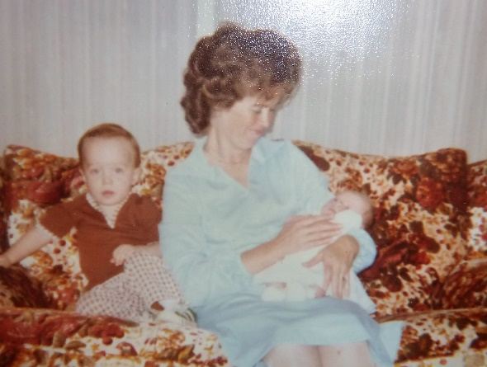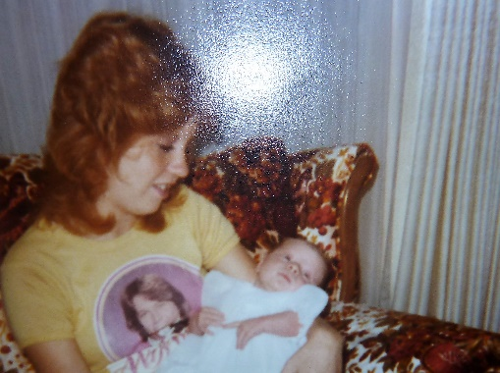When little JaNae was born, we were living in Arizona and so I took Jeff with me and flew up to help Sandi and her new baby daughter. We stayed over a week and I really enjoyed being with them. Jeff was excited to have a little niece. He was two years old at the time. Dave had been in a serious accident where he almost lost his leg. The doctor used a new procedure by putting large pins in his leg. Sandi had to dress his wounds night and morning. It was so awful that it made me sick looking at it. I don’t know how Sandi did it with being pregnant. Sandi was in her senior year of high school so after she was able to recover and go back to school, Dave put JaNae’s bassinet by the couch and he took care of her while Sandi was at school. Sandi got everything ready for his lunch, JaNae’s bottles, etc. We were very proud of Sandi for graduating from High School.

**Sandi had two special little daughters – JaNae & Chelci**. JaNae is 5 years older than Chelci. Sandi was a great mother to her girls, but Dave wasn’t a very good father. Sandi supported and helped them with everything, while Dave didn’t. Dave was more concerned with Dave, than with his family. He criticized 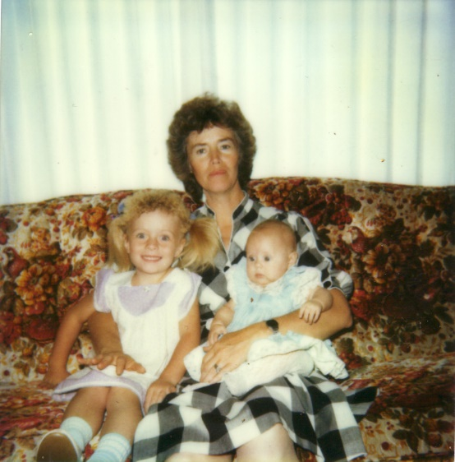Sandi and belittled her a lot. I’m sure he loved her in his own way, but he was anything but a good husband. He was a hard worker and was talented in many ways. He could fix most anything and did taxaduratry. He loved sports – baseball, hunting and fishing. He was a good provider, but that’s about all I can say. He is a lot like his father and we didn’t care much for him. Dave was a controller, and when he came home from work, Sandi had to have his dinner ready and then be at his beacon call. He wouldn’t even allow her to go walking with her friends, but that changed thank goodness when she got a job.

Sandi wanted a car and Dave told her that she would have to get a job and buy her one as he wasn’t buying her one. She applied at the school to work as a cook in the school lunch program and she was hired. That worked good for her and the girls as she was home when they were. Sandi put her girls in a “**clogging” class** and soon after the teacher asked Sandi to help her teach. Sandi has always been talented in dancing so she did. Sometime afterwards, the teacher who was a young adult and wanted to go to college asked Sandi if she would like to buy the business from her. She was able to do this and did great at this also. Sandi amazed me at how she could make up the dances, design the costumes and even sew them. She loved the girls and they loved her. She had a great business and she took her classes to different competitions all over. I went whenever I could as I enjoyed watching them. Every May she had a competition at Lagoon, so her, her daughters and other girls in her classes coming for the competition, stayed the night at our home in Layton and then I would go with them the next morning. In between the competitions, we would go on the rides at Lagoon. It was a fun time. I was always proud of Sandi, JaNae & Chelci. JaNae & Chelci took after their mother and were very talented and did very well in the competitions and looked so cute with their beautiful smiles. My mother loved to watch them dance also.

**Sandi separated from Dave, after being married for 16 years.** She has told me that she never loved him. That is sad to be married to a person you don’t love. Sandi is a “pleaser” and so she tried to work at her marriage for many years and especially for the sake of her girls. She and Chelci stayed with us the summer of ??. Sandi and I bonded more that summer than all the years of her marriage. I am thankful for that time we had together. We walked each morning and had many good talks. She was able to get her feelings out, which was good. She was so good to help with the cooking, cleaning, etc. I hated it when Dave would call her as she was finally calm and enjoying life more, but when he would call, she would start shaking all over and after she hung up, she would be so mad and upset.

I enjoyed sweet little Chelci also, and wished JaNae had come too, but she stayed with her dad as he convinced her that he needed her, and she wanted to be with her friends, etc. I could understand, but would have liked to have her with us also.

Dave finally talked Sandi into going back to him. She stayed for a few months, but they ended up getting a divorce. Sandi was able to rent an apartment close to the school, Harris Elementary in Tooele, where she was the head cook. She fixed it up really cute. Her and Chelci were happy there for about two years.

Sandi married Terry Thomas. Terry was about 15 years older than Sandi, but he was a good man, good looking and had a duplex apartment in Grantsville, just across from Grantsville High.

Sandi & Dave had joint custody with the girls. JaNae stayed with her dad and Chelci went with her mom. It is hard splitting up a family and I felt really bad for the girls, but I knew Sandi was at the point that she couldn’t take any more. When Sandi & Terry married, they remodeled his duplex apartment. That made it easier for JaNae to be with her mom & sister more. I’m very glad that she is close with her mom. JaNae was in a beauty pageant and when asked the question “Who is the person that has been the biggest influence in your life?” JaNae answered “My Mom because she has always been there for me.” She said other special things about her mom and as I was sitting by Sandi, and she was crying. We, as parents, need to hear those things at times. JaNae got in trouble from her other grandparents & her Dad because she said it was her Mom, instead of her Dad. It surely hasn’t been easy for JaNae as she was 16 at the time and that is a difficult time in a person’s life anyway. We have always kept her in our prayers. We do pray for all of our children, their spouses and our grandchildren. They are all so wonderful and we love them all so much. Ken & I have really been blessed.

(**Back to Erda)** Ken went deer hunting with our friend, Larry Braithwaite, in Manti. Larry had called and invited Ken to go with him. While they were together Larry told Ken how good he was doing in the construction business. He told Ken he should come down and offered him a good job. Ken came home excited about it as he was getting discouraged on the farm. He loved the farm and the work, but he was discouraged with the farm committee because it took them so long to make decisions and to get anything done. And on a farm, it needs to be done right now. The work crews usually didn’t show up or at least not nearly as many as were expected. He had so much work to do that he had to work such long hours and on Saturdays as well. Ken was lst counselor in the Bishopric so Sundays and week nights were tied up also. We didn’t have much time together as a family and Ken felt bad about that. Also, we were not making much money. The church doesn’t pay high wages. We took a cut in wages when we quit programming for Gary Miles and came to work for the church. But Ken had always wanted to farm and he wanted this so bad that he was willing to do this. It was a hard decision for me, but I finally agreed. After they built us such a nice home, and I came to love the ward and people in Erda, then I was glad we had moved. **But now he was asking me to move again**. Farm life wasn’t a perfect life, there were certainly disadvantages, but I was happy here. I did wish Ken had more time for the family and it would have been nice if we could make more money to be able to save and get ahead. Also, we had a big yard and big garden and since Ken was so busy on the farm, these things were left up to the children and I. It was hard work keeping it up, but it was good for the children and I enjoyed it (except for when the **nats** were out). Sometimes, however, it was overwhelming because I had a small baby who was really demanding, and I was busy with church and civic responsibilities. I taught the Beehives, they were cute girls.

We lived in Erda three years. I taught the Beehives the first two years and was a den leader the 3rd year. In those days, they didn’t have separate young women’s presidency and class teachers. We were the presidency, but we also taught the classes. The president was Hilda Cockrane and she taught the Laurels, Connie King was the lst counselor and she taught the Mia Maids, and I was the 2nd counselor and taught the Beehives. It seemed like we had lots of meetings - weekly presidency meetings plus our individual class presidency meetings and monthly stake and ward meetings. Hilda and I became good friends. They had a beautiful home in Stansberry Park. Her husband was Ken’s counselor in the High Priest’s presidency and Harvey Russell was his other counselor.

They released me when Ken was put in the Bishopric **and asked me to be a den mother. Mike and David were in my den**. I enjoyed doing this with my sons. We had a great time. We had a magic show, a country fair, several plays where we would make the scenery and costumes and perform in front of the parents, etc. Ken made me a stand to display the beads the boys earned. There was a wolf head on one side of the stand and a bear head on the other side. I think he carved them, but I’m not sure. Ken helped me many times in my church callings, and I helped him in his. I sure appreciate all he does for me.

I was also active in the Women’s Republican Organization, so with all this plus housecleaning, laundry, meals, canning fruits and vegetables, etc., it seemed almost more than I could do at times, but I still loved it here in Erda. It was work, but also fun when we canned fruits and vegetables, especially corn, as we would make it a family affair and Ken would help us. Everyone had a job. With corn, some would shuck it while other washed and cleaned it, others blanched it, another cut it off the corn cob, someone else rinsed it in ice water while others drained and bagged it. We worked together really well. I don’t remember the children arguing or complaining much. (Maybe they did, but I don’t remember it. I have good memories of doing this as a family).

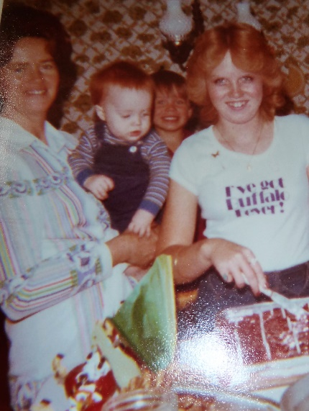When Ken started talking about quitting the farm and moving to Arizona again, I became discouraged as I didn’t want to move again and uproot the family. I told him that the Prophet said in one of the Ensigns that you shouldn’t move your family unless it is really necessary. That it was hard on all the family and sometimes not profitable. I thought he had decided to stay, but every so often he would get discouraged with the farm and think of moving again. I kept talking him out of it as we have moved so much and Ken is 40 years old now and I didn’t think we should go into building again as we have tried it twice and it hasn’t worked out. For one thing, neither Ken nor I like the uncertainly of it. Ken and the dairy farm manager flew to Arizona on a business trip to look at a feeder system. The company flew them down. They went in February. Ken called Larry to say hello, and they insisted he come spend the night. Again, Larry tried to convince Ken to come down and told him that he could make more money if he went into business for himself, and that he would help set him up in business. He told Ken that if he wasn’t making $440,000. a year, he wasn’t doing anything. Then Ron Shumway took Ken to the airport on his way to work. As they talked, Ron told Ken he would love to have him come to work in computer programming for him, and that if he had to, he would fire someone in order to get Ken on. When Ken came home he was again excited. I explained my feelings again and that I felt so secure on the farm since they provide the home, pay the utilities, we get all the milk we want, we get a beef a year, plus the garden and we’re able to have animals. We had a pig, chickens, rabbits, dog, cat and horse which provided us with eggs and lots of meat and good pets for the children. We also had insurance and the retirement was good. Ken brought up the fact that we didn’t make enough money to save for Christmas, vacations, school clothes, etc., and this had always put us behind since we came to the farm, plus we had used up most of our year’s supply and we owed money on the Visa Charge Card. He asked how we were ever going to save for the future - missions for the children, wedding receptions, etc. We discussed this back and forth.

When we learned of Sandi’s forthcoming wedding, I asked him to forget the subject of moving for a while as I surely couldn’t have it on my mind at this time. The day after the wedding, he again brought up this subject. I still didn’t feel good about it. In fact, I was making our bed at the time and I was so upset with Ken that I threw the pillow as hard as I could at him. I’m sure if I had been in the kitchen and had a frying pan in my hand, I probably would have thrown it at him. After I threw it, I was surprised and embarrassed and we both started laughing. Anyway, I felt maybe I was being selfish because I didn’t want to leave my beautiful home now that I had it just the way I wanted. I had always wanted a home just like this. I got to pick out the design of the outside of the house, the inside, decorate how I wanted, the carpeting, wall paper, drapes, tile, etc. Then I had always wanted a large yard with a white rail fence around it, and now we had all this. Both Ken and I designed the basement. Our boys’ room was a lovely big room. We had three twin beds for Mike, David and Scott. It had 3 closets, one for each boy. It had a part bathroom with shower, and vanity with two sinks and two medicine cabinets with mirrors for when they grew up and needed to shave. The one wall had cork board covered with panels of red and blue burlap. This way the boys could have a dart board and put up their posters and drawings, etc., to display them. The rest of the walls have a cute Tom Sawyer and friends with animals, etc., design on the walltex. It was really a cute room. Many of my friends came to see it and show their husbands so they might have something like it. Shellie’s room was pink with white closet doors, woodwork and white drawers and cupboards built in. She had a cute matching pink bedspread and curtains. It was really a darling room for her. We had a nice storage room where we had lots of shelves for my bottled fruit and vegetables. The freezer was there and also all my nice removable shelves that Ken built for our year’s supply of food. In the furnace room, there were also 4 nice large shelves to put our camping gear and other boxes for storage. This last winter, Ken built our family room. It was beautiful with also lots of storage. He built a cupboard under the steps and then the rest of the room under the steps he made into a coat closet to store old coats and clothes. He put a nice door on it. One whole wall had shelves across it, with levered bifold doors on them. He also built me a bookcase. I wanted him to build a box effect up and across the wall where the fireplace was and around the fireplace so it could also be carpeted and people could sit on it, which he did. Ken put white slump block on the wall above the fireplace and built up the area where the fireplace was and put red bricks underneath the place where our Heritage Stove sat. The carpeting we picked out was lush and beautiful. We had the drapes made to match the carpeting. It was really a beautiful room. The stakes felt good about it as they wanted us to have a lovely home and they also wanted the home and farm to be a good example of how our home, yards and property should be - for the rest of the church members.

The main part of the house was beautiful also. We had a lovely entranceway from the front door. The front room was off to the right. We had a beautiful fireplace, the carpet was lime green and the drapes had blue flowers with lime green stems and leaves, it was on a white background. They hung from the ceiling with white shear drapes underneath. They were very pretty. The wall where the fireplace was had a black effect in the paneling. We had seen this paneling in the model home and really liked it. It was also on both walls dividing the front room from the entrance way. On the left of the front door was the stairs leading to the basement. It also had this same paneling on the walls with the rod iron railing. The kitchen and dining room were beautiful. I had white formic on the countertops and bar. I picked out white wall tex with lime green and yellow flowers. It was really cheery. There was a window above the sink and I had sheer lime green curtains on this window and also sheer drapes on the arcade doors in the dining area, with beautiful green and white heavier drapes. I pulled these heavier drapes back to give a window effect. Off from the kitchen was the mud room where the washer and dryer were, also the pantry with bifold doors and the back outside door. I really appreciated the mud room; for in the spring, fall and winter, it was literally a “mud” rom. A hall led from the dining area to the three bedrooms and bathrooms. We had intended the one small bedroom to be my sewing room combined with Ken’s den after we put the boy’s downstairs, but then we decided to have another child, so it turned out to be a nursery for Jeff. I fixed it up really cute and put the rocking chair in there which made it really nice. Sandi’s room was done in yellow, and I made matching drapes and bedspread. It was really cute. Our room was beautiful too.

The main reason Ken told me he wanted to move was because of the changes which had occurred when President Labrum was released as the stake president over the farm. President Labrum had been wonderful to work with and had Bishop Steadman over the farm and Ken worked well with him. But, President Morrill replaced Pres. Labrum and he changed things drastically.

**I wrote a letter to President Morrill before we left the farm. This is the letter.**

Dear President Morrill, since we haven’t really talked with you recently, I felt I’d like to write to you and tell you our feelings about quitting the farm. We don’t want you to feel we’re ungrateful for all you, Pres. Labrum and the farm committee have done for us and I hope you don’t feel we are letting you down by leaving the farm. We want to leave with good feelings and no regrets. We have loved it here. It is beautiful – the fields, the house, yard and everything about the farm. In fact, as you know, I have tried to persuade Ken not to leave, for I really love it here and we have such good friends and a wonderful ward. Of course, I realize there are good people everywhere and I’m sure we will like it in Arizona. We did before. I have been concerned about Ken going into business for himself in these troubled times, but it is a good offer that Larry is giving us – to help set Ken up in business and let Ken work off his license until he gets his own. Larry says they really need finish carpenters in the Phoenix area. Larry does framing, so he would refer his finish work to Ken. I sure hope and pray it works out for the best, but we have fasted and prayed about it and we are trying to live righteously so I’m sure the Lord will bless us.

I’m sure you and the farm committee have been disappointed in your past farm managers and hired help – Clarence, Eldon, Tom, Dan and several others. With Clarence, we got so we didn’t like to be around him as he had gotten so negative. He was either complaining about his health, the long hard hours he worked, that he didn’t feel he had the support of the farm committee, the work crews not showing up, his wife’s health due to these problems, etc. After Clarence was let go, he came out here later and felt bad that he had worked these several years and given his all to the farm and after his health made it impossible to work like he had, he was replaced. He said no one thanked him or appreciated all that he had done before. He also felt bad that Eldon had taken over and was letting things get run down. We had heard that the dairy farm used to be a showplace and people from all over were brought to the farm and shown around because the church was proud of it, so I’m sure Clarence, at one time, was a good farm manager and took pride in his work. I can begin to see this happening to Ken and so I can start to realize how Clarence became this way. I certainly don’t want this to happen to Ken so maybe it’s for the best that we leave. We, too, were disappointed with Eldon and upset that he would be dishonest like it appears he was. We don’t know how you feel about us, but we don’t want to leave with you thinking we are ungrateful or letting you down, or that we are dishonest. I would hope that we can work out any problems or misunderstandings before we leave. That is my main reason for writing this letter to you.

Ken talked to Pres. Johnson, who is at the Bishops storehouse, and over the farms; the other day at church. He lives in the Stansberry ward. Ken wanted him to stop our savings program that we had sent in previously. He was shocked to hear we were quitting and he said he felt that Ken and Vern (Vern runs the Granger Stake Farm) were the two best farm managers the church had. He said he knew they were in his district. He felt bad that we couldn’t work things out to stay. Many who have been out here on the work crews have made comments like “you must really love farming to work like this at your salary.” Even Dave Williams commented that he would like to live and work on a beautiful farm like this, but they would have to pay him a lot more to do it. When LeRoy was hired, Dave said he was embarrassed to offer him such a low wage, and he would like to hire Ken as a computer programmer where he could make more money.

I know you told us several times that you felt Ken was doing a good job and you appreciated him, yet no one from the farm committee have called to tell Ken, thanks or that they are sorry to see him leave. And, by letting Kay Petersen manage both farms, Ken felt that all of you must not have thought he was very important out here since you were not replacing him and thinking Kay could run both farms. Maybe since Ken has gotten the farm in this condition, it won’t be as hard for someone to do it. I told Ken I couldn’t understand how he could think of leaving after all he’s gone through to get this farm to this point. I can honestly say he has really worked hard, and put in many long hours and done his very best to make it the farm it is. Many times, I felt he was neglecting the family and that the farm came first, but he felt he needed to take the time for the farm for there was so much to do. When we moved out here three years ago in September and moved into the home before it was completed, it was quite an ordeal. We cooked on a camp stove for over a week, used a camp cooler, lantern, brought water from the well, etc., because we didn’t have any utilities. Then each day improvements were made. They poured the basement floor and put the windows in. That really helped because the flies were so bad. Gradually we got the utilities, brick on the home, fireplace, steps and driveway and sidewalks. Then we started on the landscaping. The first two winters Ken built our two bedrooms downstairs in his spare time and this last winter, he built our beautiful family room. I guess it’s harder for me to leave all this than him, because he said he couldn’t feel good about leaving it if it wasn’t beautiful like this. I’m glad he does feel this way.

The two main reasons we are leaving, which we’ve already discussed with you are: we couldn’t feel we are building up anything for the future. We have not got a home that’s building up equity and we have not been able to afford to buy any property or put much in savings because of our low wage. In fact, we sold our home in Taylorsville to pay off some bills so we could afford to come to the farm at this low wage. Ken has always wanted to farm and he felt this would be so good for the family. The children could work with him and we’d be out in the country with animals, etc. It hasn’t worked out like he thought it would. With Ken being a perfectionist, he put in so many hours on the farm that he didn’t have much time for the family. And the children, with the exception of Sandi, were too young to help him much. They rode around on the tractor with him some, but then they would get bored and get off. He was as busy on Saturdays as the rest of the week, and when he was put in the Bishopric, that meant Sundays were really busy as well as several evenings where he could squeeze them in. One evening he came in and said he didn’t know whether it was worth it or not as he wasn’t enjoying the family like he thought he would and he didn’t know how we could afford wedding receptions, missions, etc., at the rate we were going. With this offer on his mind, he felt maybe that was the answer.

We are grateful that you let us get this nice home and put up the fence, furnishings, finish the basement, etc. I’m sure you did this to make us happy and show your appreciation. You have been good to us in many ways and we appreciate it. I will miss it and wish we could have worked it out somehow to stay. Ken feels that the problems with Dave aren’t getting any better. Dave told Ken he would get back with him about the wiring and plumbing for the big building before the weekend, but he never called. With Ken being a perfectionist, he expects the same in others. When they are supposed to do something, he expects them to follow through. I tried to tell him he needs to learn patience, but he couldn’t seem to do it and was having stomach problems because of nerves.

Another thing Ken was concerned about was Kay Petersen. When you hired Kay several months ago, you told Ken that Kay and his family were so much like us – that they even looked a lot like us, and that Kay had been a computer programmer before also. We were thrilled and excited to meet them. We liked them right from the beginning and thought we had become good friends. When Bishop Rose told Ken that Kay would manage both farms and that you said it was probably a good thing because there were problems between the two managers, you could have knocked Ken over with a feather because he was completely unaware that there had been any problems between them. He liked Kay and felt they had a good relationship. He had voluntarily offered to help remodel the one home on the dairy farm for Kay’s brother-in-law to move into since they couldn’t get the men out from the stakes to do it. Ken got behind in his spring work by doing this, but he wanted to help them out. He also heard from another source that Kay was complaining about Ken and back biting him. When Ken asked Kay about this the other day, Kay said he was unaware that there were any problems between them, that sometimes they didn’t always agree on how to repair things or go about doing things, but that was normal because they were two different men. They are two different men, and I do hope that’s all there is to it, because we have thought a lot of Kay and his family and would be disappointed to learn that he has been politicking to get this managers position. Since Kay has taken over, his attitude has changed. Both LeRoy and Ken have noticed it. One incident was the next day when Kay came out. When he got ready to leave, he hooked up the sprayer and was going to drive off with it. Ken asked him how long he would have it because he needed to use it to spray the barley field in a day or so. Kay said he didn’t know, so consequently the barley was late being sprayed. Another day Kay broke the ogger and Ken tried to tell him how to fix it, but he wouldn’t listen so he worked on it all morning and finally did it the way Ken had suggested. We had never seen this side of Kay before, and maybe it’s because he’s upset with us that we’re leaving. I hope that’s it. But his attitude seems to reflect that “I’m the manager now and I’ll make the decisions,” so Ken has let him make the decisions and take over since that seems to be what he wants. Both Kay and L.B., especially L.B., have questioned Ken about the farm, equipment, how everything works, etc. Ken is telling them everything he knows, has learned, his ideas and suggestions in order to help them.

In order that there will not be any questions as to our honesty, I’d like to tell you about Ken’s tools, the truck, telephone bill, etc. Ken had many tools when he came to the farm and when men came out and didn’t bring tools with them, he let them use his. Consequently, many have been lost or broken. He doesn’t feel he has the money to replace them himself so he told Kay about it and he told Ken to let the farm buy them to replace them. He has done this, but he feels he is being honest about it. We also want to settle up on the telephone bill, if you feel it is too high, and it could very well be, as we had to make several long-distance calls with regards to Sandi’s reception. We have used the truck for personal use occasionally when our car was broken down or transportation was critical. We tried to replace the gas, but I would like to pay $20.00 more to make sure. I hope this will be alright, for I know the truck was for farm use. This last week Ken has been fixing the motorcycle, fixing the car, as it wasn’t running right, and I didn’t want him to leave me for a month and have the car go out on me. He’s also been getting his tools together and getting things ready to leave. At nights, neighbors, friends and family have wanted to get together with us before we leave, so the evenings have been taken up pretty much. Consequently, Ken hasn’t worked as hard on the farm itself. Since Kay is making the decisions and L.B. is working out here with Bishop Rose, Ken has felt they haven’t needed him as much and he needed to take care of these things.

I want to leave the house and yard clean and neat as I know it belongs to the stakes and to the Lord and I’m thankful for the time we enjoyed it.

I would just like to say a word or two about Bishop Rose. He was disappointed that he wasn’t chosen to take over Ken’s position here on the farm and move into our home. He is a wonderful man and good farmer and he loves farming so I hope things will work out for him so he will stay. I felt really good when he accepted the offer to work here with Ken. He’s worked really well with Ken and helped him so much. I feel that with the experience he’s gained in working here on the farm with Ken, and his other farming experience, that he is really a valuable man for you. He’s been a Bishop and is now a High Counselor – so you can see that he is a spiritual man also. I don’t know how this will work with Kay managing the farm, and L.B. and Bishop Rose working together, but I surely hope it will work out for the best and that the farm will keep producing as well or better for you. Ken used to carry a notebook and pencil in his pocket and as he would see things that needed to be done, he would write them down and see that they got done. We’re not resentful about Kay being over both farms, we were surprised, but we know it was our decision to quit. We want what’s best for the Lord’s farm and we hope Kay has the farm knowledge and what it takes to make it work. Probably you’ve all prayed about it – so it will work.

I didn’t get this mailed to you when I thought I would, and Dave came out to talk with us last Sunday Evening. He was really sweet and after talking with him and his wife, we feel much better. In fact, I debated as to whether to send this letter to you now or not. I asked Dave whether he knew Kay had been complaining about Ken or not, and he said Kay thought a lot of Ken and he was sure that was not true. We feel better towards Kay and we will believe that this other was probably rumor.

I didn’t mean to write such a long letter. I guess when I got started, I didn’t know when to quit. Thank you again for everything and we hope everything turns out for the best for all of us. Sincerely, Mae Browning

P.S. Ken is unaware of me writing this letter and possibly wouldn’t approve of me doing this. So I would appreciate it if you would keep this confidential or use it with wisdom.